Erercise 4
Code1:
Input:
<!DOCTYPE html>
<html>
<head>
<title>JavaScript Demonstration</title>
</head>

<body>

<h2>JavaScript Program</h2>

<script>

let a = 10;
let b = 5;

document.write("<h3>Variables</h3>");
document.write("A = " + a + "<br>");
document.write("B = " + b + "<br>");

document.write("<h3>Arithmetic Operators</h3>");
document.write("Addition = " + (a + b) + "<br>");
document.write("Subtraction = " + (a - b) + "<br>");
document.write("Multiplication = " + (a * b) + "<br>");
document.write("Division = " + (a / b) + "<br>");

document.write("<h3>Conditional Statement</h3>");

if (a > b) {
document.write("A is greater than B<br>");
} else {
document.write("B is greater than A<br>");
}

document.write("<h3>Loop</h3>");

for (let i = 1; i <= 5; i++) {
document.write(i + "<br>");
}

document.write("<h3>Function</h3>");

function add(x, y) {
return x + y;
}

document.write("Addition using Function = " + add(a, b));

</script>

</body>
</html>

Output:
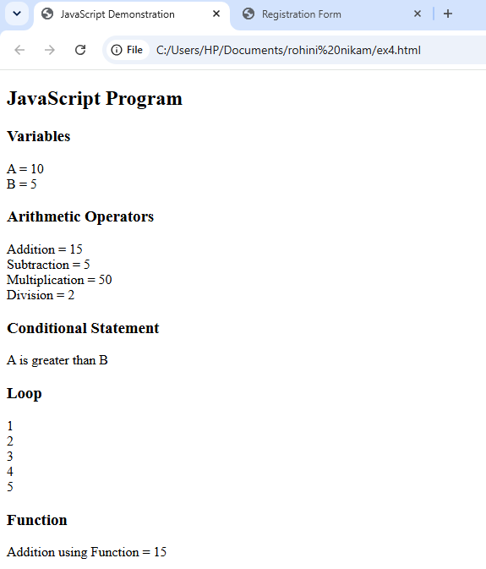

Code2:
Input:
<!DOCTYPE html>
<html>
<head>
<title>Registration Form</title>

<script>
function submitForm() {
let name = document.getElementById("name").value;
let email = document.getElementById("email").value;

if (name == "") {
alert("Please enter your name");
return false;
}

if (email == "") {
alert("Please enter your email");
return false;
}

alert("Registration Successful!");
return false;
}

function clickEvent() {
alert("Submit button clicked!");
}

function mouseOver() {
document.getElementById("msg").innerHTML =
"Ready to submit!";
}
</script>
</head>

<body>

<h2>Registration Form</h2>

<form onsubmit="return submitForm()">

Name:
<input type="text" id="name">
<br><br>

Email:
<input type="email" id="email">
<br><br>

<button type="submit"
onclick="clickEvent()"
onmouseover="mouseOver()">
Submit
</button>

<p id="msg"></p>

</form>

</body>
</html>
Output:
